**ER DIAGRAM AND CONCEPTUAL SCHEMA:**

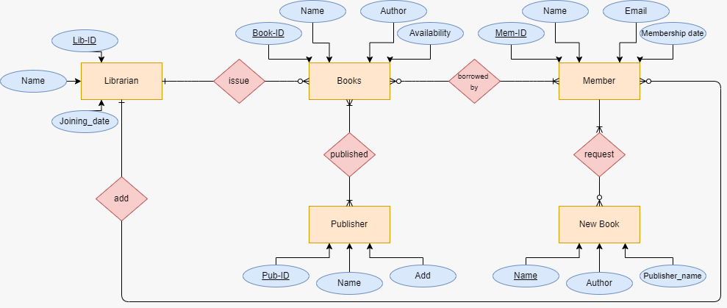

**Schema:**

+-----------+ +---------+ +-----------+

| Author |<----Writes---->| Book |<----Published By----| Publisher |

+-----------+ +---------+ +-----------+

|

| Borrows (via Loan)

v

+-----------+ +---------+ +------------+

| Member |<----Loan---->| Loan |<----Manages----| Librarian |

+-----------+ +---------+ +------------+

**Converted Relational Schema**

**Entities and Relationships:**

|  |  |  |
| --- | --- | --- |
| **Table name** | **Attributes (primiary keys)** | **Foreign keys** |
| **Publisher** | PublisherID, Name, Address, Contact | None |
| **Book** | ISBN, Title, PublishedYear, Genre, Availability | PublisherID → Publisher.PublisherID |
| **Member** | MemberID, Name, Email, Phone, JoinDate | None |
| **Loan** | LoanID, IssueDate, DueDate, ReturnDate ReturnDate | MemberID → Member.MemberID, ISBN → Book.ISBN, LibrarianID → Librarian.LibrarianID |
| **Book_Author** | ISBN, AuthorID | ISBN → Book.ISBN, AuthorID → Author.AuthorID |
| **Author** | AuthorID, Name, Nationality | None |
| **Publisher** | Librarianid, name, Email | None |

**Normalization Process**

1NF (First Normal Form)

Ensured all attributes are atomic.

**Example:** The Book_Author table resolves the many-to-many relationship between Book and Author.

**2NF (Second Normal Form)**

Removed partial dependencies.

Example: Loan table uses LoanID (surrogate key) to ensure all attributes depend on the full PK.

**3NF (Third Normal Form)**

Removed transitive dependencies.

Example: Publisher table stores only publisher-specific attributes (no redundancy).

**Final 3NF Relations**

**Publisher:**

Publisher (PublisherID, Name, Address, Contact)

**PK**: PublisherID

**No transitive dependencies**: All attributes directly depend on PK.

**Book**

Book (ISBN, Title, PublisherID, PublishedYear, Genre, Availability)

**PK**: ISBN

**FK**: PublisherID → Publisher.PublisherID

**3NF Compliance**: No attributes depend on non-PK fields.

**Author**

Author (AuthorID, Name, Nationality)

**PK:** AuthorID

**Member**

Member (MemberID, Name, Email, Phone, JoiningDate)

**PK**: MemberID

**Librarian**

Librarian (LibrarianID, Name, Email)

**PK:** LibrarianID

**Loan**

Loan (LoanID, MemberID, ISBN, LibrarianID, IssueDate, DueDate, ReturnDate)

**PK:** LoanID

**FK:** MemberID → Member.MemberID, ISBN → Book.ISBN, LibrarianID → Librarian.LibrarianID

**Book_Author**

Book_Author (ISBN, AuthorID)

**Composite PK**: ISBN, AuthorID

**FK:** ISBN → Book.ISBN, AuthorID → Author.AuthorID